Chapter: Abstraction for Programming (5 Hours)
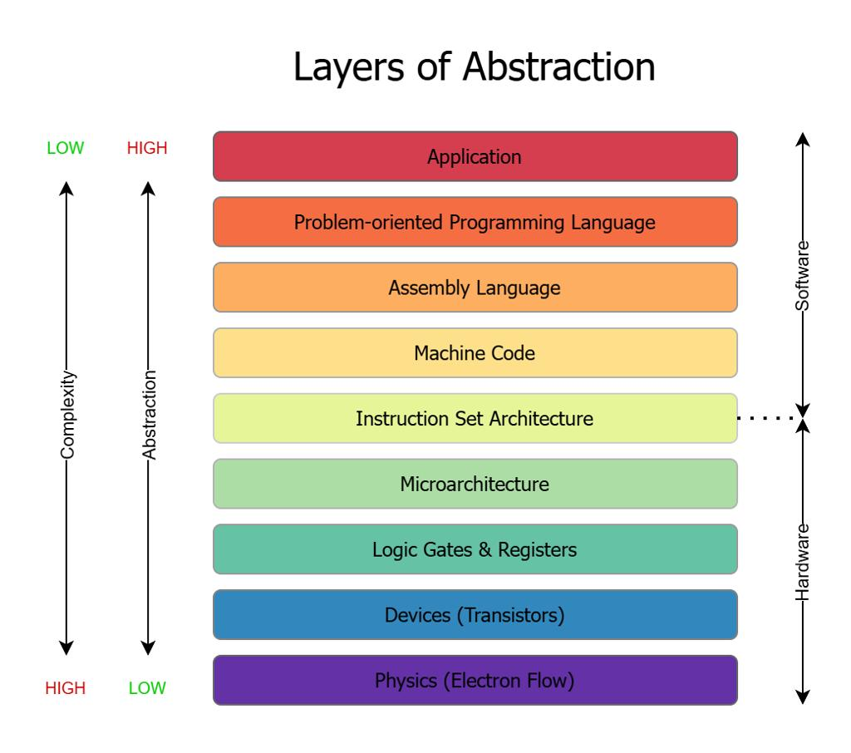
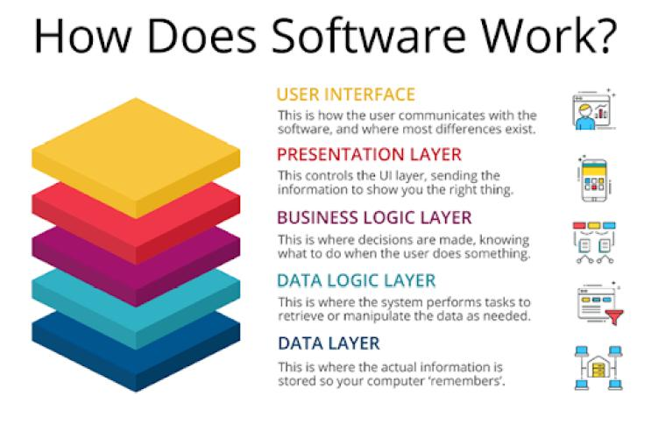
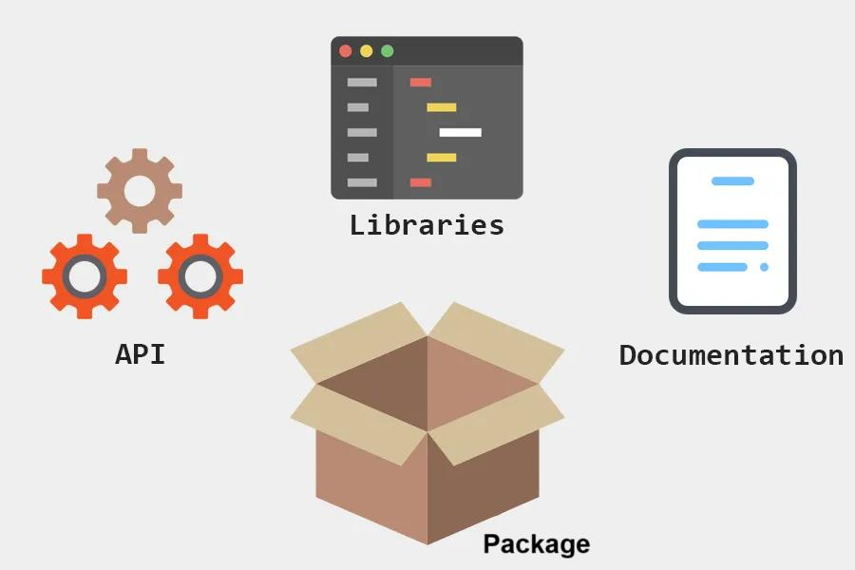
7

Learning Objectives
After studying this chapter, students will be able to:
- Define abstraction in programming.
- Explain different levels of abstraction in computer systems.
- Understand the role of libraries, system software, and toolkits.
- Describe the importance of high-level programming languages.
- Explain the concepts of Object-Oriented Programming (OOP).
- Compare abstraction mechanisms used in modern software development.
- Apply abstraction principles in software engineering and multimedia application development.

1. Introduction to Abstraction

What is Abstraction?
Abstraction is the process of hiding unnecessary implementation details while exposing only the essential features needed to perform a task.
It enables programmers to solve complex problems without understanding every low-level hardware or software operation.

Definition
Abstraction is a software engineering principle that simplifies system design by hiding implementation details and exposing only the necessary functionality through well-defined interfaces.

Simple Real-Life Example

Driving a Car
When driving a car, the driver uses:
- Steering wheel
- Accelerator
- Brake
- Gear
The driver does not need to know:
- How fuel is injected
- How pistons move
- How the engine control unit works
The car provides an abstraction of a very complex mechanical system.

ATM Machine
When withdrawing money:
You only:
- Insert the ATM card
- Enter the PIN
- Select the amount
You do not see:
- Database queries
- Banking servers
- Encryption algorithms
- Network communication
The ATM hides these implementation details.

Programming Example
Instead of writing instructions directly to hardware, a programmer can use a library function:
#include <iostream>
using namespace std;

int main()
{
cout << "Hello World";
}
The programmer does not need to know:
- How characters are stored in memory.
- How the operating system writes to the screen.
- How the graphics driver controls the monitor.
The library and operating system provide the abstraction.

Why is Abstraction Important?
Abstraction helps programmers:
- Reduce complexity.
- Improve code readability.
- Increase productivity.
- Reuse existing components.
- Simplify maintenance.
- Develop large-scale software.
- Enhance software portability.

Advantages of Abstraction
Advantage | Description
Simplicity | Reduces system complexity
Reusability | Reuses existing components
Maintainability | Easier to modify and debug
Security | Hides sensitive implementation details
Portability | Runs on different hardware platforms
Productivity | Faster software development

Disadvantages
- Slight performance overhead.
- Hidden implementation can make debugging more difficult.
- Improper abstraction can reduce flexibility.

2. Abstraction Levels
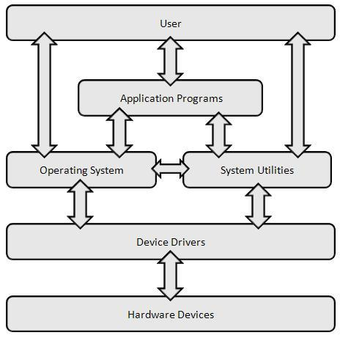
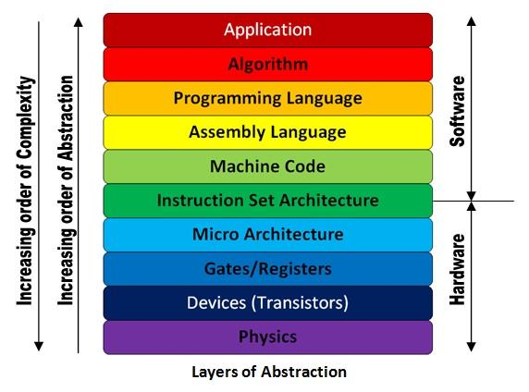
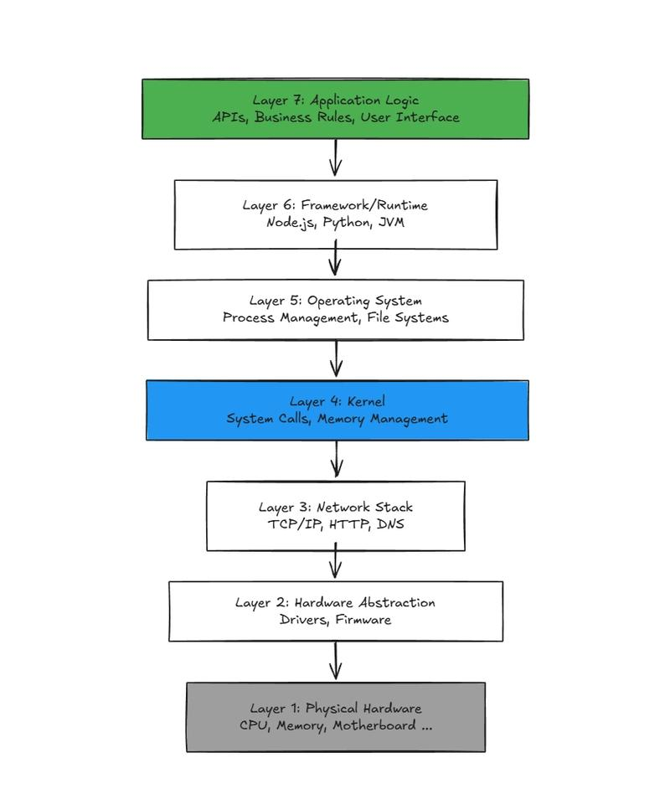
6
Programming is organized into multiple layers. Each layer hides the complexity of the layer below it.
+----------------------------------+
| User Applications |
+----------------------------------+
| Programming Libraries |
+----------------------------------+
| Programming Languages |
+----------------------------------+
| Operating System |
+----------------------------------+
| Device Drivers |
+----------------------------------+
| Computer Hardware |
+----------------------------------+

Level 1: Hardware Level
The lowest abstraction level.
Includes:
- CPU
- Memory (RAM)
- Hard Disk/SSD
- GPU
- Keyboard
- Mouse
- Network Interface Card

Example
CPU executes binary instructions such as:
10110010
Programming directly at this level is difficult.

Level 2: Machine Language
Machine language consists entirely of binary instructions.
Example
10110000 01100001
Characteristics
- Fastest execution
- Hardware dependent
- Difficult to write
- Difficult to debug

Level 3: Assembly Language
Assembly language uses mnemonic instructions.
Example
MOV AX,10
ADD AX,5
Advantages
- Easier than machine language
- Efficient
- Hardware dependent

Level 4: High-Level Languages
Examples
- C
- C++
- Java
- Python
- C#
- JavaScript
Example
print("Hello")
Advantages
- Easy to understand
- Portable
- Faster development
- Large library support

Level 5: Application Level
Applications include:
- MS Word
- Photoshop
- VLC Media Player
- Web Browsers
- Multimedia Editors
Users interact only with this highest level.

Comparison of Abstraction Levels
Level | Users | Complexity | Examples
Hardware | Engineers | Very High | CPU, RAM
Machine Language | System Programmers | Very High | Binary instructions
Assembly | Embedded Developers | High | MOV, ADD
High-Level Language | Software Developers | Moderate | Python, Java
Application | End Users | Very Low | MS Word, VLC

3. Libraries

Definition
A library is a collection of pre-written, reusable functions, classes, or modules that programmers can use without writing everything from scratch.
Libraries increase productivity and reduce code duplication.

Types of Libraries

Standard Libraries
Provided with programming languages.
Examples:
- C Standard Library (stdio.h, math.h)
- Java Standard Library
- Python Standard Library

Third-Party Libraries
Developed by external organizations or communities.
Examples:
- OpenCV (Computer Vision)
- NumPy (Scientific Computing)
- TensorFlow (Machine Learning)
- Pygame (Game Development)

Example (C)
#include <math.h>

double value = sqrt(25);
The programmer calls sqrt() without implementing the square-root algorithm.

Multimedia Libraries
Examples:
- OpenCV
- SDL (Simple DirectMedia Layer)
- OpenGL
- DirectX
- FFmpeg
These provide ready-made functions for graphics, video, and audio processing.

Advantages of Libraries
- Save development time.
- Improve reliability.
- Reuse tested code.
- Simplify complex tasks.

4. System Software

Definition
System software manages computer hardware and provides a platform for application software.
It acts as an intermediary between users, applications, and hardware.

Types of System Software

Operating System
Examples:
- Windows
- Linux
- macOS
- Android
Functions:
- Process management
- Memory management
- File management
- Device management
- Security

Device Drivers
Allow the operating system to communicate with hardware devices.
Examples:
- Printer driver
- Graphics driver
- Audio driver

Language Translators
Convert source code into machine code.
Types:
- Compiler
- Interpreter
- Assembler

Utility Software
Examples:
- Antivirus
- Disk Cleanup
- Backup software
- Compression utilities

System Software Architecture
User
│
Application Software
│
Operating System
│
Device Drivers
│
Hardware

Importance of System Software
- Controls hardware resources.
- Provides user interfaces.
- Executes application programs.
- Ensures system security and stability.

5. Toolkits

Definition
A toolkit is a collection of software tools, libraries, APIs, documentation, and utilities designed to help developers build specific types of applications.
Unlike a simple library, a toolkit usually includes multiple integrated resources.

Components of a Toolkit
- Libraries
- APIs
- Compilers
- Debuggers
- Documentation
- Templates
- Sample projects

Examples

Multimedia Toolkit
- OpenCV
- SDL
- Qt Multimedia
- FFmpeg

Mobile Development Toolkit
- Android SDK
- Flutter SDK

Game Development Toolkit
- Unity
- Unreal Engine

Advantages
- Faster development.
- Better integration.
- Cross-platform support.
- Rich documentation.

6. Higher Programming Languages

Definition
High-level programming languages allow programmers to write code using syntax that is close to human language rather than machine instructions.

Characteristics
- Easy to read.
- Easy to write.
- Portable.
- Structured.
- Supports modular programming.
- Supports object-oriented programming.

Examples
Language | Common Applications
C | System programming
C++ | Games, multimedia
Java | Enterprise software
Python | AI, ML, multimedia
C# | Desktop and game development
JavaScript | Web development
PHP | Web applications

Comparison
Feature | Low-Level | High-Level
Readability | Low | High
Portability | Low | High
Development Speed | Slow | Fast
Hardware Dependency | High | Low

7. Object-Oriented Approaches (OOP)
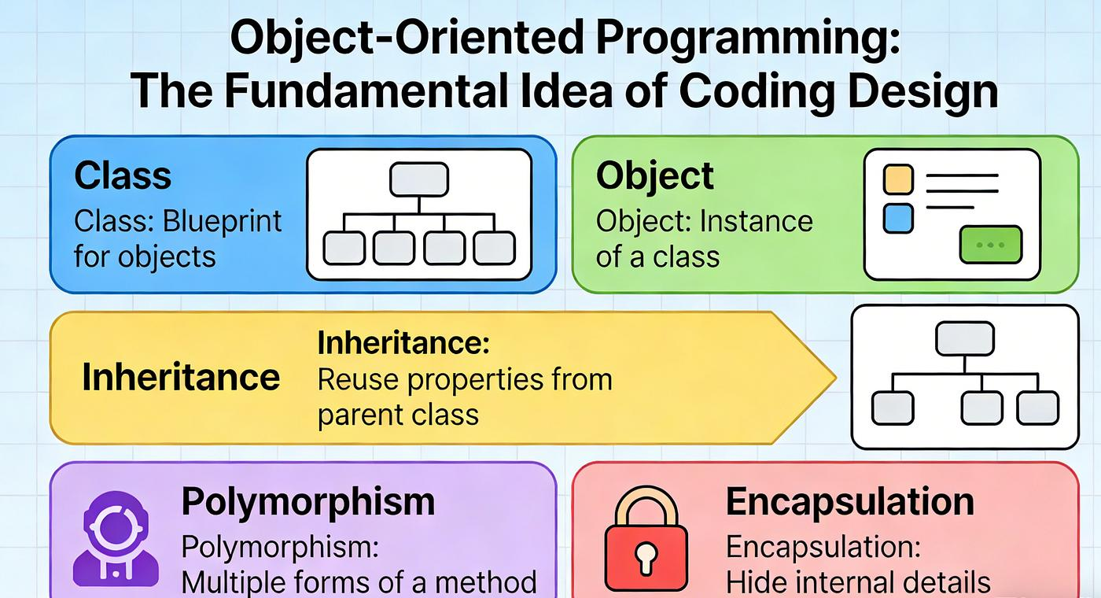
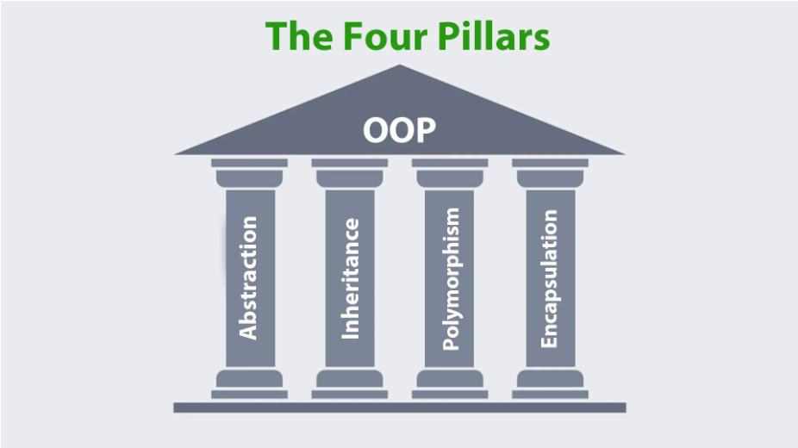
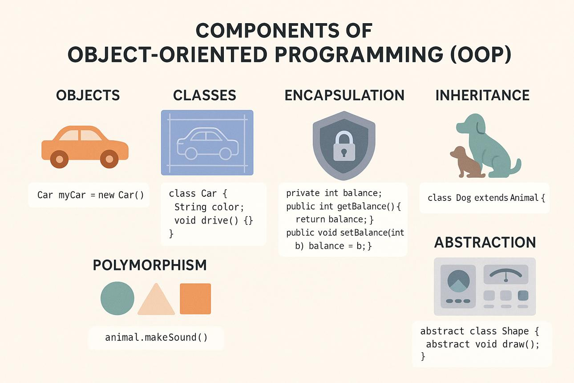
6

Definition
Object-Oriented Programming (OOP) is a programming paradigm that organizes software into objects, which combine data (attributes) and methods (functions).
Objects represent real-world entities.

Example

Class
Student

Object
Ram
Hari
Sita
Each student object has:
Attributes:
- Name
- Roll Number
- Address
Methods:
- Study()
- AttendClass()
- SubmitAssignment()

Four Main Principles of OOP

1. Encapsulation
Combines data and methods into a single unit (class) and restricts direct access to internal data.

Example (Java)
class Student {
private String name;

public void setName(String n){
name = n;
}

public String getName(){
return name;
}
}
Advantages
- Data protection
- Improved security
- Easier maintenance

2. Abstraction
Shows only essential features and hides implementation details.
Example:
car.start();
The user does not need to know how the engine starts internally.

3. Inheritance
Allows a class to inherit properties and methods from another class.
Example
Animal
/ \
Dog Cat
Benefits:
- Code reuse
- Easier maintenance
- Reduced duplication

4. Polymorphism
Allows one interface to represent multiple implementations.

Example
Shape
│
┌─┴─────┐
Circle Rectangle
Both implement:
draw()
but each provides its own behavior.

Benefits of OOP
- Code reuse
- Modularity
- Scalability
- Easier debugging
- Better maintainability
- Improved software design

Applications of OOP
- Multimedia software
- Game development
- Mobile applications
- Banking systems
- E-commerce platforms
- Artificial Intelligence
- Healthcare systems

Summary
Topic | Key Points
Abstraction | Hides implementation details and exposes essential features
Abstraction Levels | Hardware → Machine Language → Assembly → High-Level Languages → Applications
Libraries | Reusable collections of functions and classes
System Software | Operating systems, drivers, translators, and utilities
Toolkits | Integrated collections of tools, libraries, APIs, and documentation
High-Level Languages | Human-readable languages such as C, C++, Java, and Python
Object-Oriented Programming | Organizes programs using classes and objects
OOP Principles | Encapsulation, Abstraction, Inheritance, and Polymorphism

Advantages of Programming Abstraction
- Simplifies software development.
- Encourages code reuse.
- Improves readability and maintainability.
- Reduces development time.
- Enables portability across platforms.
- Supports large-scale software engineering.

